








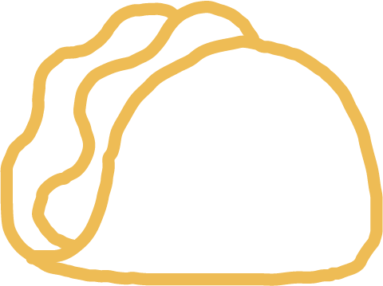



5-ingredient santa rocky road bars

Makes 60

INGREDIENTS
3½ slabs (300g) NESTLÉ Aero Milk
100g margarine
¾ pack (150g) vanilla biscuits
1 slab (80g) NESTLÉ Milkybar Original
12 (11g each) NESTLÉ KitKat Santas

METHOD
- Line a square dish (23x23cm) with baking paper, ensuring that it hangs over the sides.
- Break the NESTLÉ Aero Milk slabs into smaller cubes and add to a large microwave-safe bowl. Add the margarine to the chocolate.
- Microwave on high for 1-2 minute, stirring in 15 second intervals until melted. Allow to cool to room temperature.
- Break the vanilla biscuits into small chunks and fold it through the cooled chocolate sauce until well dispersed.
- Transfer and press the mixture into the prepared baking dish, using a spatula to even it out. Refrigerate until needed.
- Break the NESTLÉ Milkybar Original into smaller cubes and melt it in the microwave, stirring at 15 second intervals until smooth. Pour the white chocolate over the rocky road layer and arrange the NESTLÉ KitKat Santas on top of the melted Milkybar layer, facing upward.
- Allow the rocky road to set in the fridge for 2 hours.
- Using the baking paper to lift, transfer the rocky road to a cutting board. Dip a sharp knife in hot water and slice the rocky road into equal portions.
- Serve and ENJOY or pop the festive rocky road squares into a jar as a gift to someone special.

